HackerEarth Program 3
Link :- https://www.hackerearth.com/problem/algorithm/digit-sum-4/
Successful Submission
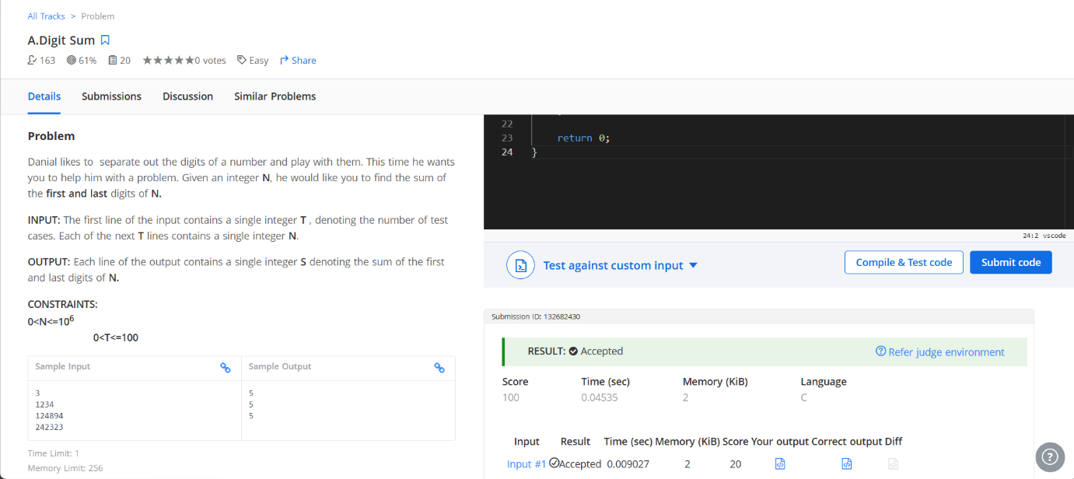
Source Code


